ACCENTURE TEST 3

1. Find the missing term in the series given below.

EGJ, NOP, LNQ, RTW, TUV?

1. XZC (c) YAD
2. XYZ (d) XYC

Ans: [a]

2. Find the missing term in the series given below.

ABD, CFJ, EFH, GJN, IJL?

1. KMQ (c) MPT
2. KNR (d) KMR

Ans: [b]

3. Mark the odd one out from the given options.

(a)Dividers (c) Eraser

(b)Protractor (d) Compass

Ans: [d]

4. Mark the odd one out from the given options.

(a) FDB (c) NKH

(b) USQ (d) KIG

Ans: [c]

5. Mark the option that best completes the comparison.

King: Kingdom? Empire

1. Emperor (c) Royal
2. Soldier (d) Throne

Ans: [a]

6. If in a certain code language, “ASTRONAUTS” is coded as “BUWVPPDYUU”, then

how would “GOVERNMENT” be coded in the same code language

1. HQYISPPIOV (c) HQYISPPIPV
2. HQIYKKTOPS (d) HQZHTSROSV

Ans: [a]

7. Mark the options that best completes the comparison.

Confrontation: conflict: enormous?

1. Miniature (c) petite
2. Monstrous (d) small

Ans: [c]

8. If in a certain code language, “NOTES” is coded a “OQWIX”, then how would “SIREN” be coded in the same code language?

(a) TKJHI (c) TJSFO

(b) TOPLK (d) TKUIS

Ans: [d]

9. If in a certain code, bus means ship, ship means plane, plane means submarine and submarine means cycle; what mode of transport do you need to travel underwater?

(a) Bus (c) Plane

(b) Ship (d) Submarine

Ans: [c]

10. From the Response Figure identify which should complete the sequence given in the problem figure.

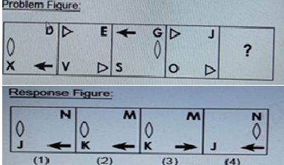

1. 4 (c) 1
2. 2 (d) 3

Ans: [ ]

11. Find the missing term in the series given below.

6, 19, 44, 81? 191

1. 130 (c) 143
2. 120 (d) 128

Ans: [a]

12. Find the missing term in the series given below.

18, 24, 32? 54

1. 42 (c) 46
2. 43 (d) 45

Ans: [a]

13. n a certain code language,” ACQUIRE” is written as “ZXJFRIV”, then how would “nymphos” be coded in the same code language.

(a) KEWSNYU (c) QESUYBA

(b) MBNKSLH (d) QESUYBA

Ans: [b]

14. The Problem Figure given below has the properties of a lattin Square. Each blank cell in the Problem Figure will contain an item based on the following properties of the Latin square.

1.A row or column never contains the same twice.

2.Same items are there in every row

3. Same items are there in every column

From the items given in the Response Figure, choose the one that should come in place of “?” in the Problem Figure.

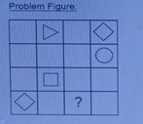 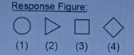

1. 3 (c)2
2. 4 (d) 1

Ans: [2]

15. If the ground is called yellow, yellow is called green, green is called grass, the grass is called blue, blue is called water and water is called pink, then what is the color of fresh grass?

(a) Grass (c) Green

(b) Water (d) Blue

Ans : [a]

16. If “SNAPE” is coded as “68213” and “GEORGE” is coded as “435743”, then how would “GRANGER” be coded in the same code language?

(a) 4782473 (c) 4728437

(b) 2685416 (d) 2587265

Ans: [c]

17. Mark the odd one out from the given options.

(a) 2,4,8 (c) 3,6,9

(b) 4,8,16 (d) 1,1,1

Ans: [c]

18. Find the missing term in the series given below.

H, 66, V ,488, N, 202, P?

1. 248 (c) 284
2. 264 (d) 244

Ans: [b]

19. Which one of the following images is most unlike the other three?

(a) 1 (c) 3

(b) 2 (d) 4

Ans: [c]

20. You have a Spanish word document with you and you want to see only the translation of the heading in English. Which of these would you use Translate Document

I. Translate Selected Text

II. Mini Translator

Choose the correct answer from the options given below.

1. Only II & III (c) Only I & II
2. All I, II & III (d) Only I & III

Ans: [ ]

21. Which of these layout options allows you to wrap text around an object?

1. Tight (c) Through
2. All of the mentioned options (d) Square

Ans: [ ]

22. You want to insert a keyboard sequence in a word document to insert the special character ©. Which of these keys would you need to hold down while entering the appropriate keyboard sequence?

(a) Shift (c) Tab

(b) Alt (d) Ctrl

Ans: [ ]

23. If you are required to compare the value of several series of data, which of the following kind of Power point chart types should be selected?

(a) doughnut (c) Surface

(b) Bubble (d) Radar

Ans: [ ]

24. In which of these options would you be able to see the given image and use a decaying wave?

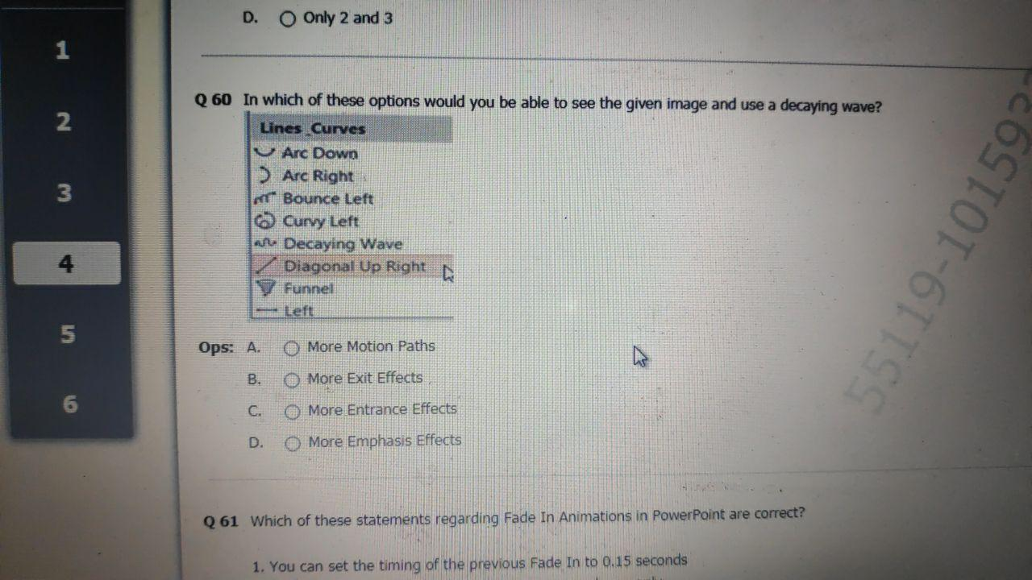

1. More Motion Paths (c) More Entrance Effects
2. More Exit Effects (d) More Emphasis Effects

Ans: [ ]

25. Which of these statements regarding Fade in Animations in PowerPoint are correct?

1. You can set the timing of the previous Fade In 0.15 seconds

2. Fade In is used to make the animations appear slower only

3. Fade In is used to make the animations appear quicker only

Choose the correct answer from the options given below.

1. Only 1 and 3 (c) Only 1
2. Only 1 and 2 (d) Only 2

Ans: [c]

26. You have created an animation for a group of objects, and now you want to apply the same animation to another object. Which of the following buttons can used in such a scenario?

1. None of the mentioned options (c) Animation Painter button

(b) Style Painter button (d) Format Painter button

Ans: [ ]

27. You have already selected all the text in a Word document using Ctrl +A. What shortcut key could you use to remove of all hyperlinks in document.

1. Ctrl+Shift+F4 (c) Ctrl+Shift+F9
2. Ctrl+Shift+F7 (d) Ctrl+Shift+F5

Ans: [ ]

28. What are the features of MS Word?

1. Clarity, accessibility, stability, build test scenarios
2. Maintenance, efficiency, usability, reliability, portability
3. Functionality, simplicity, modularity, design
4. Compatibility, local and cloud support, build in collaboration, saving and printing

Ans: [ ]